IYPT2025第38届国际青年物理学家竞赛中英文版赛题及图解、参考视频~~

IYPT青年物理学家

IYPT/CUPT
1. Invent Yourself: Paper Boomerang
Make a returning boomerang from a sheet of paper by folding and/or cutting. Investigate how its motion depends on relevant parameters.
1.自制纸飞镖
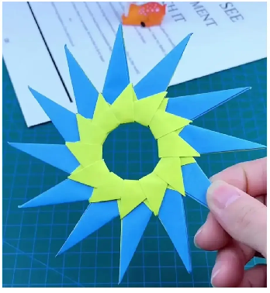
用一张纸通过折叠和/或裁剪制作一个能返回的飞镖。研究其运动如何取决于相关参数。

2. Air Muscle
Place a balloon inside a cylindrical net (as is sometimes used to wrap garlic) and inflate it. The net will expand and shorten. Investigate the properties of such a “muscle”.
2. 气动肌肉
将一个气球放入圆柱形网（如常用于包裹大蒜的那种）中并充气。网会膨胀并缩短。研究这种“肌肉”的性质。
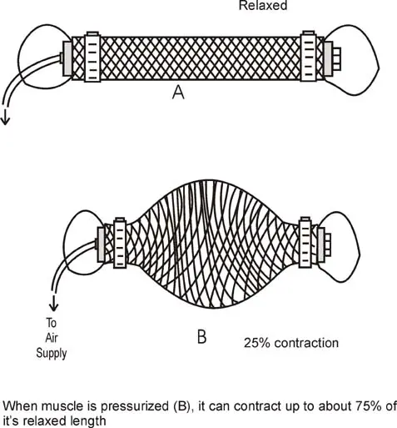

3. Lato Lato
Attach a ball to each end of a string and connect the center of the string to a pivot. When the pivot oscillates along the vertical direction, the balls start to collide and oscillate with increasing amplitude. Investigate the phenomenon.
3.拉托拉托
将两个球分别系在一根绳子的两端，绳子的中点连接到一个枢轴上。当枢轴在垂直方向上振荡时，球开始碰撞并以增加的振幅振荡。研究这一现象。
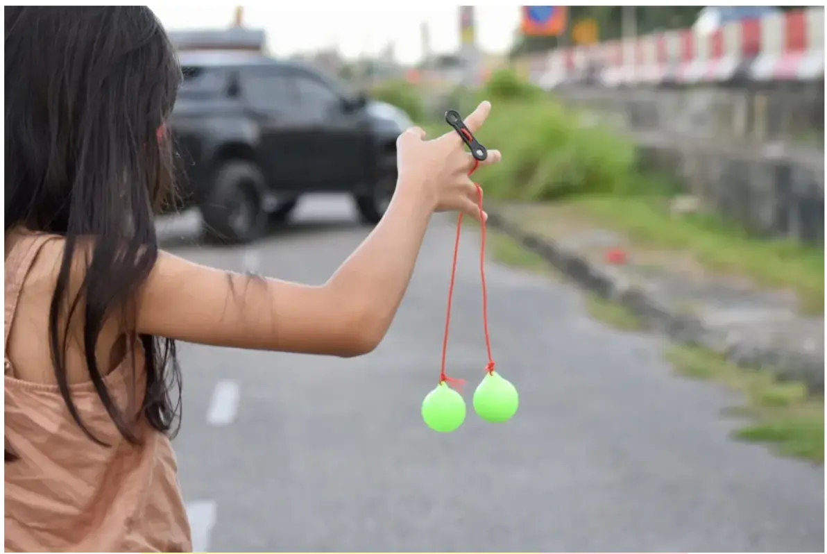

4. Climbing Magnets
Attach a rod assembled from cylindrical neodymium magnets horizontally to a vertical ferromagnetic rod. Limit the motion of the magnets to the vertical direction. When the ferromagnetic rod is spun around its axis of symmetry, the magnetic rod begins to climb up. Explain this phenomenon and investigate how the rate of climbing depends on relevant parameters.
4. 攀爬磁铁
将一个由圆柱形钕铁硼磁铁组成的杆水平地附着在垂直的铁磁杆上。限制磁铁的运动方向为垂直方向。当铁磁杆绕其对称轴旋转时，磁杆开始向上攀爬。解释这一现象并研究攀爬速率如何取决于相关参数。
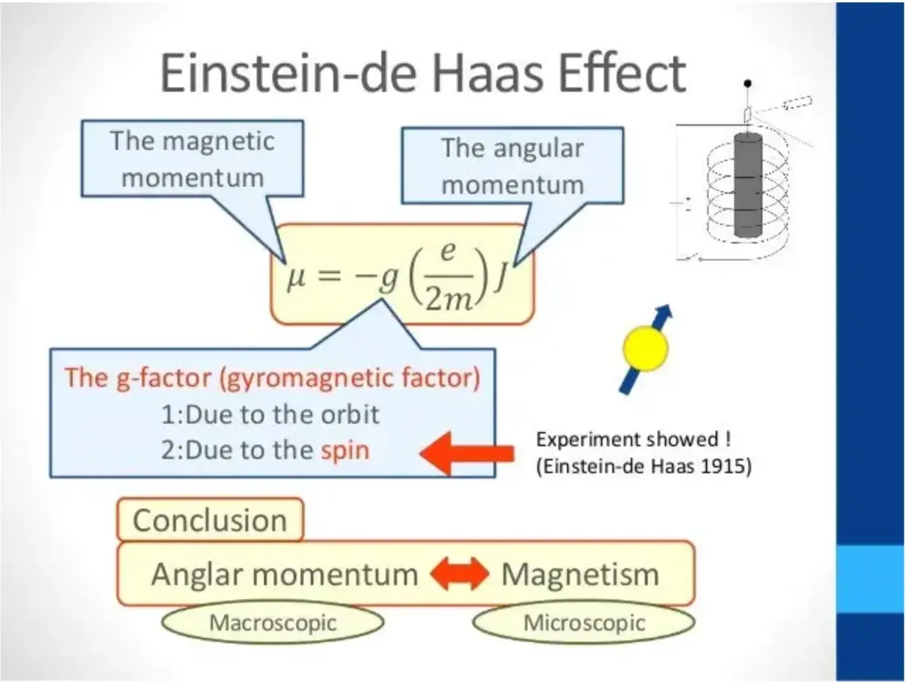

5. Dancing Slinky
Twist a slinky several times and keep its bottom fixed. After releasing the top, the slinky starts to “dance” – wave-like phenomenon can be observed from the side-view. Explain the phenomenon and investigate the parameters affecting the slinky’s motion.
5. 跳舞的弹簧玩具
将弹簧玩具（如Slinky）多次扭转并固定其底部。释放顶部后，弹簧玩具开始“跳舞”——从侧面观察可以看到波浪状现象。解释这一现象并研究影响弹簧玩具运动的参数。

6. Dripping Faucet
A leaky faucet develops interesting dripping patterns, where the time between drops depends on the water flowrate. Investigate this phenomenon and study how it depends on relevant parameters.
6. 滴水龙头
漏水的水龙头会形成有趣的滴水模式，其中水滴之间的时间间隔取决于水流速度。研究这一现象并研究它如何取决于相关参数。

VS

7. Ruler Cannon
Two rulers are tightly held against each other. A round projectile (e.g. a plastic bottle cap or a ball) is inserted between them close to one of their ends. When extra force is exerted on the surface of the rulers, the projectile is ejected at a high speed. Investigate this effect and the parameters that affect ejection speed.
7. 尺子加农炮
两把尺子紧紧靠在一起。将一个圆形射弹（如塑料瓶盖或小球）插入两把尺子之间靠近它们的一端。当在尺子表面施加额外的力时，射弹会以高速射出。研究这一效果以及影响射出速度的参数。
8. Levitating Fluid
When a container partially filled with liquid is oscillated vertically and air is injected at the bottom of the container, the fluid can “levitate”. Investigate the phenomenon.
8. 悬浮液体
当一个部分装有液体的容器在垂直方向上振荡，并且在容器底部注入空气时，液体会呈现“悬浮”状态。研究这一现象。

9. Magnetic Assist
Attach one or two magnets to a non-magnetic and non-conductive base such that they attract a magnet suspended from a string. Investigate how the motion of the moving magnet depends on relevant parameters.
9. 磁力辅助
将一个或两个磁铁附着在非磁性且非导电的基座上，以便它们吸引一个通过绳子悬挂的磁铁。研究移动磁铁的运动如何取决于相关参数。

10. Rayleigh–Bénard convection
Uniformly and gently heat the bottom of a container containing a suspension of powder in oil (e.g. mica powder in silicon oil), cell-like structures may form. Explain and investigate this phenomenon.
10. 瑞利-贝纳德对流
均匀且温和地加热装有油中有悬浮粉末（如硅油中的云母粉）的容器底部，可能会形成类似细胞的结构。解释并研究这一现象。

参考文献：Chen Jun, Shen Chao-Qun, Wang He, Zhang Cheng-Bin. Rayleigh-Bénard-Marangoni convection characteristics during mass transfer between liquid layers. Acta Phys. Sin., 2019, 68(7): 074701. doi:10.7498/aps.68.20181295
11. Spring Hysteresis
Connect two identical linear springs symmetrically to a mass in a “V” shape, and apply an adjustable force to the mass. When this force is varied, the resulting motion of the mass depends on the history of changes in the applied force under certain conditions. Investigate this phenomenon.
11. 弹簧滞后
以“V”形对称地将两个相同的线性弹簧连接到一个质量块上，并对质量块施加一个可调节的力。在特定条件下，当这个力变化时，质量块的运动取决于施加力的变化历史。研究这一现象。
参考文献：Hysteresis in a simple V-shaped spring-mass system，June 2021American Journal of Physics 89(7):663-665
12. Sound Versus Fire
A small flame can be put out by sound. Investigate the parameters of the flame and characteristics of the sound that determine whether the flame will be extinguished.
12. 声音与火
声音可以熄灭小火。研究火焰的参数和声音的特性，以确定火焰是否会被熄灭。

13. Spaghetti Accelerator
When a piece of spaghetti is pushed into a bent tube, small debris of spaghetti may be ejected from the other end of the tube at a surprisingly high speed. Investigate this phenomenon.
13. 意大利面加速器
当把一根意大利面推入一个弯曲的管子时，管子的另一端可能会以惊人的高速喷出小块的意大利面碎屑。研究这一现象。

14. Water Bottle Rocket
Pump air into a plastic water bottle partially filled with water. Under certain conditions, the bottle is launched and flies into the air. Investigate how the acceleration during lift-off depends on relevant parameters.
14. 水瓶火箭
向部分装有水的塑料水瓶中打气。在特定条件下，水瓶会被发射并飞向空中。研究起飞过程中的加速度如何取决于相关参数。

15. Wailing Bowl
When you strike the side of a metal bowl containing some water, you can hear a characteristic sound. The sound changes when the water in the bowl is moving. Explain and investigate the phenomenon.
15. 哭泣的碗
当你敲击装有水的金属碗的侧面时，会听到一种特有的声音。当碗中的水在移动时，声音会发生变化。解释并研究这一现象。

16. Wirtz Pump
A Wirtz Pump is a hollow spiral, mounted vertically. It is arranged such that one end dips below water once per revolution, while the other end (at the center of the spiral) is connected to a vertical tube. When rotated, it can be used to pump water to a great height. Explain this phenomenon and investigate how relevant parameters affect the pumping height.
16. 维尔茨泵
维尔茨泵是一个垂直安装的空心螺旋装置。它被设计成每转一圈，一端就会浸入水中一次，而另一端（螺旋的中心）则连接到一个垂直的管子上。当旋转时，它可以用来将水抽到很高的高度。解释这一现象并研究相关参数如何影响抽水高度。

17. Quantum Fingerprint
Shine laser light onto an organic polymer (eg. styrofoam). The scattered light may have a higher or lower wavelength than the incident light. Explain the phenomenon and determine what can be concluded about the molecular structure of the material from the wavelength shift.
17. 量子指纹
将激光照射到有机聚合物（如聚苯乙烯泡沫）上。散射光的波长可能比入射光长或短。解释这一现象，并确定从波长偏移中可以得出关于材料分子结构的哪些结论。

